 | Our date: 2012-09-10  Your date: | Our ref.:  Your ref.:
Secretariat of ISO/TC 79/SC 5 | ISO/TC 79/SC 5 N 244
附件2：

Resolutions of the 19th meeting of ISO/TC79/SC5
In Berlin, Germany, Aug. 29th, 2012

Resolution 1: ISO/NP 16309-1 Magnesium and magnesium alloys-fatigue testing-Part 1: Axial force controlled method
Japan should find 2 more experts from other countries to participate in ISO/NP 16309-1 Magnesium and magnesium alloys-fatigue testing-Part 1: Axial force controlled method, and finish Form 4 and draft standard for this item. Then secretariat launches the ballot for this NP again.

Resolution 2: ISO/NP 17596 Method of analyzing oxygen for evaluation magnesium and magnesium alloys
UK and Germany will nominate experts to participate in ISO/NP 17596 Method of analyzing oxygen for evaluation magnesium and magnesium alloys and Japan should finish Form 4 and draft standard for this item. Then secretariat launches the ballot for this NP again.

Resolution 3: ISO/NP 26202 Magnesium and magnesium alloys-Magnesium alloys for cast anodes
Germany and Korea will nominate experts to participate in ISO/NP 26202 Magnesium and magnesium alloys-Magnesium alloys for cast anodes. The ISO committee TC 156 (cathodic corrosion protection of internal and external objects) will be contacted to coordinate the standardize activities of both committees. Japan should finish Form 4 and draft standard for this item. Then secretariat launches the ballot for this NP again.

Resolution 4: ISO/NP 16220 Magnesium and magnesium alloys -- Magnesium alloy ingots and castings
Germany will nominate Mrs. Barbel as the expert for ISO/NP 16220 Magnesium and magnesium alloys -- Magnesium alloy ingots and castings and UK will nominate expert to participate in this item after the meeting.
Japan will send their questions about alloys for strip-casting (to delete the table with mechanical properties, and to add 2 other alloys: AZ61 and AZ91, for strip-casting) to secretary after the meeting and secretary would deliver it to all delegates then.
Korea and China will modify the ISO/WD 16220 according to the comments from Japan and other countries.

Resolution 5: NPs from Japan
Japan should finish Forms 4 and drafts for 2 new NPs including Magnesium and magnesium alloys – Determination of tin, Magnesium and magnesium alloys – Determination of beryllium. Secretariat will launch the new ballots after received corresponding documents from Japan. Germany should look for an expert in addition with three experts, Japan, Korea, and China.

Resolution 6: Secretariat of ISO/TC79/SC5
Suggestion from Japan about changing of secretariat of ISO/TC79/SC5 is rejected.
(See email from ISO/CS on this item)

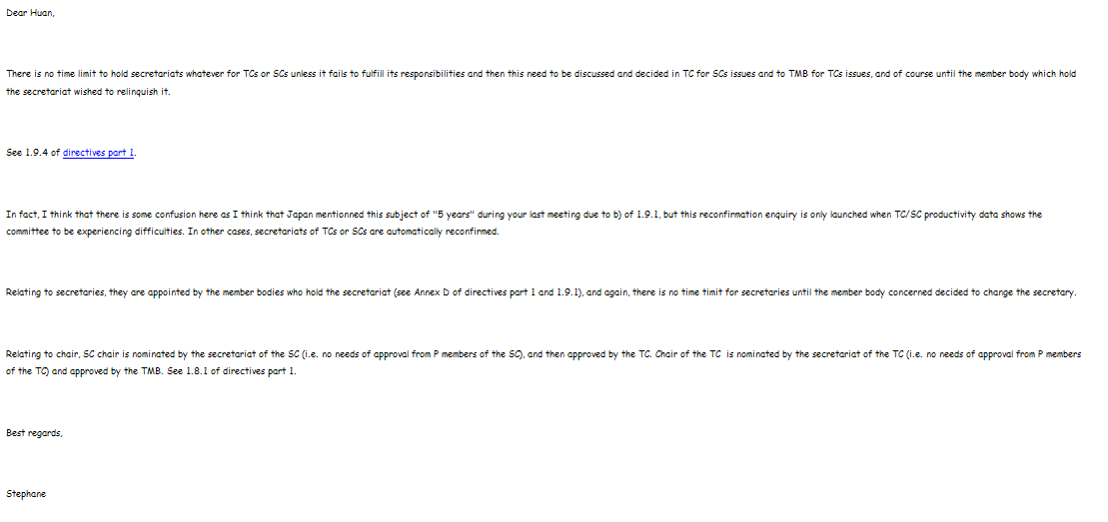

Resolution 7: Next meeting
Next meeting of ISO/TC79/SC5 will be held together with the plenary meeting of ISO/TC79.

Xi Huan
Secretary of ISO/TC 79/SC 5

