IIS
Test method of magnetic properties of isotropic bonded rare-earth permanent magnetic powder
各向同性稀土粘结永磁粉磁特性测量方法
（English Translation）

20XX-XX-XX发布 20XX-XX-XX实施
GB/T XXXXX—20XX

B
ICS 77.120.99
CCS H 65
Issued by General Administration of Quality Supervision, Inspection and
Quarantine of the People's Republic of China
Standardization Administration of the People's Republic of China

Implementation date: 202X-XX-XX
Issue date: 202X-XX-XX发布
National Standard of the People's Republic of China

Foreword
China Rare-earth Standardization Technical Committee (SAC/TC 229) is in charge of this English translation. In case of any doubt about the contents of English translation, the Chinese original should be considered authoritative.

Please note that some contents of this document may involve patents. The issuing authority of this document does not bear the responsibility of identifying patents.

This standard is drafted in accordance with the rules given in the GB/T 1.1—2020.
This standard was prepared by SAC/TC229.
Test method of magnetic properties of isotropic bonded rare-earth permanent magnetic powder

1 Scope
This document specifies the closed-circuit measurement method of the main magnetic properties of remanence, coercivity, intrinsic coercivity, and maximum magnetic energy product of isotropic rare-earth permanent magnetic powder.

This document is applicable to the measurement of the main magnetic properties of isotropic NdFeB permanent magnetic powder and SmFeN permanent magnetic powder.

2 Normative references
The following referenced documents are indispensable for the application of this document. For dated references, only the edition cited applies. For undated references, the latest edition of the referenced document (including any amendments) applies.

GB/T 2900.4 Electrotechnical terminology - Special alloys for electrical equipment
GB/T 2900.60 Electrotechnical terminology-Electromagnetism
GB/T 3217 Permanent magnet (magnetically hard) materials-Methods of measurement of magnetic properties
GB/T 8170 Rules of rounding off for numerical values & expression and judgement of limiting values
GB/T 9637 Electrotechnical terminology--Magnetic materials and components
GB/T 27418-2017 Guide to the evaluation and expression of uncertainty in measurement
JJF 1829 Calibration specification for magnetic measuring instruments for permanent magnet materials

3 Terms and definitions
The following terms and definitions of GB/T 2900.4, GB/T 2900.60, GB/T 3217 and GB/T 9637 are applied to this document.

3.1
effective cross sectional area A_{eff}
After the powder is pressed into a cylindrical test sample, the area of the equivalent circular cross-section of the dense sample without pores is calculated.

3.2
effective diameter d_{eff}
After the powder is pressed into a cylindrical test sample, the diameter of the equivalent circular cross-section of the dense sample without pores is calculated.

3.3
theoretical density of powder ρ_{t}
The density of powder materials in a pore-free state.

4 Method summary
The magnetic field strength is measured with a H coil with the corresponding H induced voltage integrator, and the magnetic polarization intensity is measured with a J coil with the corresponding J induced voltage integrator measurement. In a changing magnetic field, the change in magnetic intensity induced by H coil and the change in magnetic polarization intensity induced by J coil , and the $∆J$ are calculated using formula (1). When measuring magnetic powder sample, the cross-sectional area A in formula (1) is equal to the effective cross-sectional area A_{eff} of the magnetic particle specimen.During the measurement process, the change values ​​of the magnetic intensity and the magnetic polarization intensity are obtained at the same time, and the demagnetization curve is drawn through the measuring device, that is, the magnetic polarization intensity-magnetic field intensity curve. Calculate the value of magnetic induction intensity through formula (2), and draw the magnetic induction intensity-magnetic field intensity curve at the same time. The main magnetic properties of the tested sample are determined by the values ​​corresponding to the corresponding points on the curve. The measurement principle is shown in Figure 1.
$∆J=J_{2}-J_{1}=\frac{1}{NA}\int_{t_{1}}^{t_{2}}{Udt}$………………………………………（1）
In the formula:
$∆J$——The variation in magnetic polarization intensity, the unit is Tesla (T);
J₁——Instantaneous magnetic polarization intensity at t₁ , the unit is Tesla (T);
J₂——Instantaneous magnetic polarization intensity at t₂, the unit is Tesla (T);
A——The cross-sectional area of ​​the specimen, the unit is in square meters (m²);
N——The number of turns of the measuring J coil;
——The integral of the induced voltage within the time period of t₁ and t₂, the unit is Weber (Wb).
$B=J+μ_{0}H$…………………………………………………(2)
In the formula:
B —— Magnetic induction intensity, the unit is Tesla(T);
J —— Magnetic polarization intensity, the unit is Tesla(T);
$μ_{0}$—— Magnetic constant 4π×10⁻⁷, the unit is Henry per meter (H/m);
H —— Magnetic field strength, the unit is Ampere per meter (A/m).
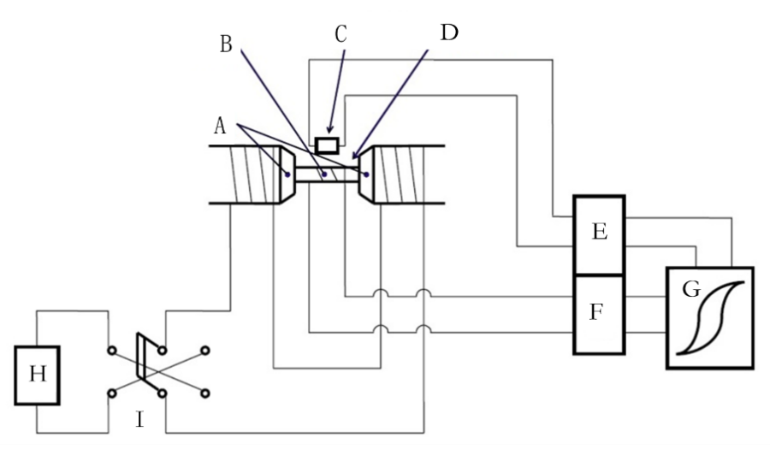
Index symbol description:
A——Electromagnet pole head;
B—— test sample;
C ——H coil;
D ——J coil;
E ——H (magnetic field strength) measuring device, usually an induced voltage integrator;
F ——J (magnetic polarization intensity) measuring device, usually an induced voltage integrator;
G——X-Y recorder;
H——magnetizing power supply;
I——transfer switch.
Figure 1 Measurement device diagram

5 Measuring devices and parameters
5.1 The measuring device should comply with the requirements for demagnetization curve measurement in GB/T 3217. The device parameters are as follows:
—— Magnetic induction intensity range: 0T~1.5T;
—— Magnetic field intensity range: 0kA/m~2000kA/m;
—— Measurement accuracy: magnetic induction intensity is less than or equal to ±0.5%, magnetic field strength is less than or equal to ±0.5%;
—— When the gap between the two pole surfaces is 10mm, the electromagnet excitation magnetic field intensity range: 0 kA/m~2000 kA/m.
5.2 Magnetic measuring devices are calibrated in accordance with JJF 1829.
5.3 Measurement instruments such as sample size and weight should be calibrated regularly.

6 Sample and preparation method
6.1 Sample
6.1.1 The particle size range of the permanent magnet powder used for pressed test samples, expressed as the median particle diameter (D50), should be 40μm~160μm.
Note:D50 is the median particle size, which corresponds to the particle size when the cumulative particle size distribution mass percentage reaches 50%.
6.1.2 The sample is a cylindrical shape of Φ10mm*10mm, and is a composite composed of magnetic powder pressed in a non-magnetic sample sleeve, as shown in Figure 2.
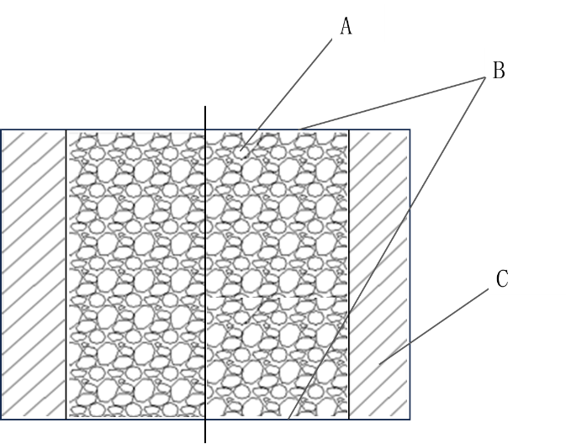
Index symbol description:
A——Permanent magnetic powder;
B ——Thin tape paper (polypropylene tape thickness is less than or equal to 0.05mm);
C——Non-magnetic sample sleeve.
Figure 2 Sample in the sleeve

6.1.3 The powder should be compacted so that it is fixed during the test, and the sample density should be (5.4±0.4)g/cm³.
6.1.4 The upper and lower sides of the sample should be parallel to each other and perpendicular to the axis of the sample. There should be no defects such as missing edges or gaps. The depressions or protrusions on the surface of the sample end should be less than 0.2mm, and there should be no delamination or shedding of magnetic powder on the surface.
6.1.5 The effective cross-sectional area A_{eff} of the cylindrical specimen is measured in square meters (m²), according to the formula(3)calculation,

$A_{eff}=\frac{m_{p}}{ρ_{t}h}$ …………………………………………………(3)
In the formula:
A_{eff}——effective cross-sectional area, the unit is square meter (m²);
m_{p}——powder mass, the unit is kilogram (kg);
ρ_{t}——Theoretical density of powder, the unit is kilogram per cubic meter (kg/m³);
h——The height of the cylindrical specimen, the unit is meter(m).

Effective diameter d_{eff} is measured in meters (m),is calculated according to formula (4):
$d_{eff}=\sqrt{\frac{4m_{p}}{πρ_{t}h}}$………………………………………………（4）
In the formula:
d_{eff}——effective diameter， the unit is meters (m);
m_{p}——Powder mass, the unit is kilogram (kg);
ρ_{t}——Theoretical density of powder, the unit is kilogram per cubic meter (kg/m3);
h——The height of the cylindrical specimen, the unit is meter (m);
Note:The theoretical density of NdFeB material is 7.6×10³kg/m³, and the theoretical density of SmFeN material is 7.67×10³ kg/m³.
6.2 Sample preparation
6.2.1 Sample preparation device
The sample preparation device consists of a sample mold (see Figure 3) and a powder pressing device (see Figure 4).
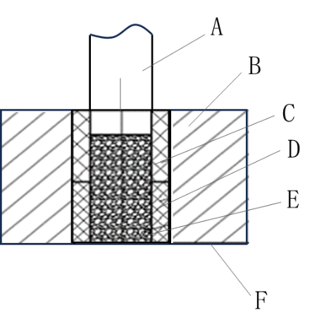
Index symbol description:
A——Upper punch;
B——Die mold;
C——Punch jacket on upper die;
D——Sample set;
E——Permanent magnetic powder;
F——Thin tape paper.
Figure 3 Sample mold

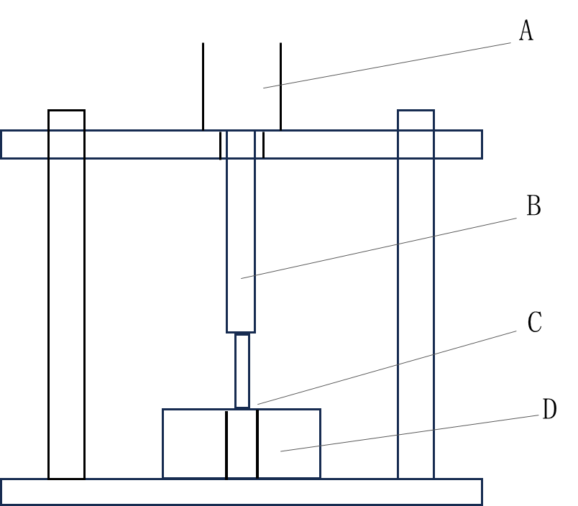
Index symbol description:
A——Hydraulic cylinder;
B——Piston;
C——Upper die punch;
D——sample mold.
Figure 4 Powder pressing device

6.2.2 Preparation method
6.2.2.1 Clean the sample mold. The cleaned sample mold should be free of powder and other dirt residues.
6.2.2.2 Seal one end of the sample sleeve with a thin circular tape, ensuring that the edge of the circular tape is between the inner and outer diameters of the sample sleeve. Weigh its mass and record it as W₀.
6.2.2.3 Assemble the sample mold, place the sample sleeve and upper mold punching outer sleeve into the mold, as shown in Figure 3.
6.2.2.4 Weigh the magnetic particle mass calculated based on the volume and density of the sample set at (5.4 ± 0.4) g/cm³ using a balance. Load the magnetic powder into the volume of the combination of the sample sleeve and the upper die punching outer sleeve, adjust the powder to be flat, place the sample mold on the powder pressing device, and adjust it to be in the center.
6.2.2.5 Under appropriate pressure P (225MPa~375MPa), press for a certain distance and hold for 3-5 minutes to ensure that the permanent magnetic powder is pressed into the sample sleeve, and the end face of the sample and the end face of the sample sleeve are flush.
6.2.2.6 After pressing is completed, unload the pressure, take out the sample mold and sample sleeve, and check the bonding condition of the powder inside the sample sleeve. If it is found that the sample does not meet the requirements of 6.1.4, return to step 6.2.2.1 to make a new sample.
6.2.2.7 If the sample produced is qualified, clean the excess powder on the outer wall of the sample sleeve and the outer edges of both ends, weigh its total mass, and record it as m_{t}. The actual mass of powder loaded into the sample sleeve is m_{p}=m_{t}-m₀.
6.2.2.8 Symmetrically stick the other end of the sample sleeve with thin adhesive tape.

7 Main magnetic properties measurements
7.1 The measurement of main magnetic properties should be carried out at a temperature of 23°C ± 3°C. The measurement sample should be placed in an environment that meets the conditions for more than 1 hour before measurement.
7.2 Pre-magnetize the sample to saturation in a pulse magnetic field with a magnetic field intensity not less than 3 times the intrinsic coercive force (H_{cJ}) of the material.
7.3 The test specimen should be clamped between the electromagnet pole heads to eliminate the expansion effect produced during pre-magnetization and reduce the air gap.
7.4 The sample is placed in the uniform magnetic field area of ​​the two pole surfaces of the electromagnet pole head, and the pre-magnetization direction is consistent with the direction of the magnetic field.
7.5 The detection coil should be in the middle of the specimen.
7.6 Input the effective cross-sectional area (or effective diameter), mass and other parameters of the sample into the testing device, and use the B-H measuring instrument to draw the J (H) demagnetization and B(H) demagnetization curve under the effective cross-sectional area of the sample curve.The main magnetic properties should be kept with three significant figures after the decimal point. The retention of significant figures shall be in accordance with the rules of GB/T 8170.

8 Determination of main magnetic properties
8.1 Residual magnetism B_{r}
The residual magnetization B_{r} or J_{r} is taken as the magnetic induction intensity value at the intersection of the B (H) demagnetization curve or J (H) demagnetization curve with the B or J axis (see Figure 5).
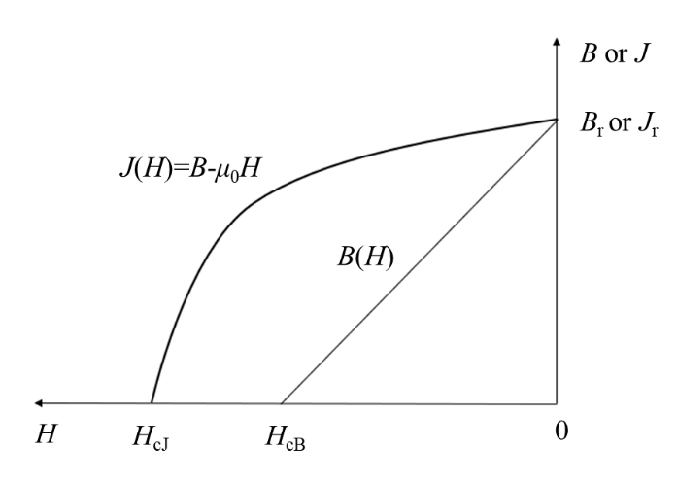
Figure 5 Demagnetization curves of J(H) and B(H)

8.2 Magnetic induction coercivity H_{cB} and intrinsic coercivity H_{cJ}
The magnetic induction coercivity H_{cB} is the magnetic field strength value at the intersection of the demagnetization curve B(H) and the straight line B=0, and the intrinsic coercivity H_{cJ} is the magnetic field strength value at the intersection of the demagnetization curve J(H) and the straight line J=0, as shown in Figure 5.
8.3 Maximum magnetic energy product (BH)_{max}
The maximum magnetic energy product (BH)_{max} is the maximum value of the corresponding product of B and H on the demagnetization curve, with corresponding B and H values of B_{a} and H_{a}, respectively, or determined by the method of tangent between the demagnetization curve and the equal magnetic energy curve (see Figure 6).
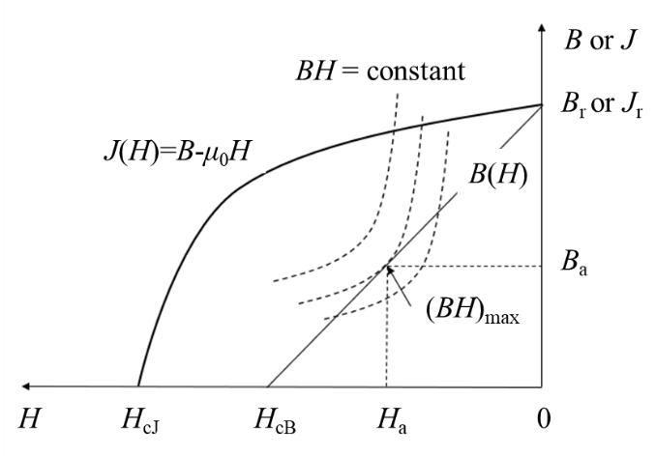
Figure 6 Schematic diagram of maximum magnetic energy product (BH)_{max}

9 Uncertainty
The uncertainty of measurement results mainly comes from:
a) The uncertainty of measurement repeatability covers random differences such as different testers, sample placement positions, and the degree of adhesion between the sample and the pole during testing;
b) The uncertainty of instruments and equipment mainly consists of the uncertainty components introduced during magnetic field strength measurement, magnetic polarization strength measurement, temperature measurement, and sample size measurement. If self demagnetization correction is applied to the results, the contribution of uncertainty caused by this also needs to be considered. According to the provisions of GB/T 27418-2017, uncertainty evaluation is conducted. Table 1 shows the extended uncertainty of the main magnetic characteristic parameters, residual magnetism (B_{r}), magnetic induced coercivity (H_{cB}), intrinsic coercivity (H_{cJ}), and maximum magnetic energy product (BH)_{max}.
Table 1 Expanded uncertainties of the main magnetic characteristic parameters
Residual magnetism expanded uncertainty  U_{rel}(B_{r}) | Magnetic induction coercivity expanded uncertainty U_{rel}(H_{cB}) | Expanded uncertainty of intrinsic coercivity U_{rel} (H_{cJ}) | Maximum magnetic energy product expanded uncertainty U_{rel}[(BH)_{max}]
<1.00% | <1.50% | <1.50% | <2.00%
Note: The ambient temperature during the test is 25℃, take the inclusion probability p=95%, and the inclusion factor k=2.

10 Test report
The test report may include the following content as needed:
——Types and grades of permanent magnet powder materials;
——Theoretical density of powder;
——The effective cross-sectional area or effective diameter of the sample, and the density of the sample;
——Model and name of the device;
——Residual magnetism B_{r};
——Magnetic induction coercivity H_{cB} and intrinsic coercivity H_{cJ};
——Maximum magnetic energy product (BH)_{max} value;
——Demagnetization curve;
——Ambient temperature during measurement;
——This document number.

