ICS 77.160
H 26
National Standard of the People’s Republic of China
GB/T XXXX-20XX

Method of ultrasonic inspection for cemented carbide
硬质合金超声检测方法
（English translation）

Issue date: 20XX—XX—XX Implementation date: 20XX—XX—XX

Issued by: General Administration of Market Supervision of the People’s Republic of China Standardization Administration of the People’s Republic of China
Foreword

SAC/TC 243 is in charge of this English translation. In case of any doubt about the contents of English translation, the Chinese original shall be considered authoritatively.

This standard is drafted in accordance with the rules given in the GB/T 1.1-2009.

This standard was proposed by China Nonferrous Metals Industry Association.

This standard was prepared by SAC /TC 243-Nation technical committee of Stardardization for Nonferrous Metals.

Method of ultrasonic inspection for cemented carbide

Scope
This standard specifies a methods of A type ultrasonic pulse contact method for cemented carbide ultrasonic longitudinal wave detection.

This standard specifies the dimensions of cemented carbide products with a height of 10,0mm ～380,0mm and a detection area not less than 113mm^{2,},orcemented carbide bar with a diameter not less than 6.0mm and a length of 40,0mm ～ 380,0mm.

Normative references
The following referenced documents are indispensable for the application of this document. For dated references, only the edition cited applies. For the undated references, the latest edition of the referenced document(including any amendments)applies.

GB/T 3488.1-2014,Cemented carbide_ Metallographic determination of microstructure(Ⅰpart:Metallographic photographs and descriptions)

GB/T 3500-2008,Powder metallurgy-The term

GB/T 9445,Nondestructive testing- personnel qualification and certification

GB/T 12604.1-2005,Nondestructive testing-The term,Ultrasonic testing

GB/T 18694,Nondestructive testing-Ultrasonic testing,Characterization of the probe and sound field

GB/T 18852,Nondestructive testing-Ultrasonic testing,A reference block and method for measuring the acoustic beam characteristics of the contact probe

JB/T 10061,Type A pulse reflection ultrasonic flaw detector-General technical

Terms and definitions
For the purposes of this document, the terms and definitions given in GB/T 12604.1-2005,GB/T 3488.1-2014,GB/T 3500-2008,and the following apply.

3.1 hole

The hole size ≥25 microns in metallographic grinding surface.

3.2 mixed material

Mixing in the mixture with another component or the size of other brands of mixing.

3.3 cobalt concentration

Cobalt enrichment region in metallographic grinding surface which is different from normal tissues.

3.4 tungsten carbide agglomeration

Gathering of thick tungsten carbide.

3.5 clutter

Reflection waveform shaped like grass.

4 General requirements
4.1 Personnel engaged in ultrasonic testing of cemented carbide is to be trained according to the GB/T9445 requirements and shall obtain the qualification certificate of ultrasonic testing and identification issued by the relevant authorization of the state. Eligible to issue ultrasonic test report if you have obtained the qualification level of GradeⅡ or above.

4.2 The detection surface of the tested cemented carbide products (excluding cemented carbide bars) should be first ground, the surface roughness Ra value should not be greater than 4.0μm, and the detection surface of cemented carbide bars should be flat.

4.3 The testing site should not be in high temperature, humidity, high frequency, strong magnetic, electric spark, vibration, mechanical noise environment, so as not to affect the accuracy and stability of the detection.

4.4 The coupling agent generally uses the mixture of glycerol and water (volume ratio is 1:4), and The coupling agent for the detection of bar products uses pure glycerol; if necessary, the oil can be used as the coupling agent for the detection of easily corroded products.

5 Performance of instrument and equipment
5.1 Ultrasonic test

5.1.1 The technical specifications of the A pulse reflective ultrasonic detector shall conform to the JB/T 10061 regulations and shall be tested regularly.

5.1.2 Determination of starting wave width of A type pulse reflection ultrasonic testing instrument and probe combination : it is suggested that divides the range of measurement of detector set up to 50 mm, then locate probe into acoustic distance 15 mm Ф 0,5mm flat bottom hole block. Adjust the detector when Ф 0,5 mm flat bottom hole reflection wave at 80% of full scale of oscilloscope screen, read the width at this time at a height of more than 20% after the initial wave on the time axis. For the probe with a nominal frequency of 5MHz, its initial pulse width is suggested to be no more than 15,0mm. For probes with a nominal frequency of 10MHz, the initial pulse width is suggested to be no more than 10,0mm.

5.2 Probe

5.2.1 A probe performance test method shall comply with GB/T 18694、GB/T 18852 relevant regulations.

5.2.2 Table 1 is suggested for the selection of probes as specified in the standard.
Table 1 Probe and probe frequency
detecting depth，mm | probe selection | nominal frequency of probe, MHz | diameter of probe, mm
10,0～20,0 | Twin crystal straight probe | 5,0 | 14,0
﹥20,0～150,0 | Single crystal straight probe | 5,0～10,0 | 6,0～14,0
﹥150,0～380,0 | Single crystal straight probe | 5,0 | 8,0～14,0

6 Requirement of ultrasonic testing for comparison blocks
6.1 The basic requirements

It is suggested that the noise amplitude of the comparison block should not exceed 20% of the full scale of the oscilloscope under the detection initial sensitivity.

6.2 Material

It is suggested to use the material similar to the tissue composition of the inspected part to ensure the consistency of its acoustic performance.

6.3 Grain size

The average grain size of the test block material is suggested in table 2.
Table 2 Average grain size of test block material
Dimensions in micrometer
average grain size of the comparison block | applicable to tested products of average grain size
1,2 | ≤2,0
2,4 | ＞2,0

6.4 Size and allowable deviation of flat bottom hole block

The schematic diagramand size toleranceof the flat bottom hole block aresuggested in fig. 1.
The size and allowable deviation are suggestedin table 3.
Table 3 Size and allowable deviation of flat bottom hole block
Dimensions in millimetres
detecting depth | Height(or length), H | Diameter, φD | hole depth of the flat bottom, h | hole diameter of the flat bottom, φA
10,0～20,0 | 20,0±0,1 | 30±0,1 | 10,0±0,3 | 0,5±0,05
﹥20,0～85,0 | 85,0±0,3 | 30±0,1 | 10,0±0,3 | 0,5±0,05
﹥85,0～150,0 | 150,0±0,5 | 20±0,1 | 10,0±0,3 | 0,8±0,05
﹥150,0～380,0 | 380,0±1,0 | 10±0,1 | — | —

6.5 Flat bottom hole test block shape and position tolerance

The schematic diagramand size toleranceof the flat bottom hole block aresuggested in fig. 1.

Figure 1 Flat bottom hole block

7 Detection methods

7.1 Testing requirement

Under the specified detection sensitivity, it is suggested that the noise amplitude of the inspected products More than 20% of the full scale of the oscillograph screen, and the signal-to-noise ratio greater than 3 times. If there are special requirements, both parties are suggested to negotiate.

7.2 Detection sensitivity

It is suggested to adopt the dB value corresponding to 80% of the reflection wave amplitude of the flat bottom hole of the comparison block in table 3, and the corresponding compensated dB value as the initial sensitivity of the tested product, and the results are suggested to adopt table 4.When the detection depth is > 150,0mm ~ 380,0mm, it is suggested to use the height (or length) of 380.0mm in table 4 as a comparison block, and adjust the instrument so that its clutter amplitude dB value is 20% of oscillograph screen full scale as the detection sensitivity.

Table 4 Initial sensitivity corresponding to the detection depth of the product under test
Dimensions in millimetres
detecting depth | Height(or length), H | Diameter, φD | hole depth of the flat bottom, h | hole diameter of the flat bottom, φA | Initialsensitivity（dB）
10,0～20,0 | 20,0±0,1 | 30±0,1 | 10,0±0,3 | 0,5±0,05 | ￠+4
﹥20,0～85,0 | 85,0±0,3 | 30±0,1 | 10,0±0,3 | 0,5±0,05 | ￠+3
﹥85,0～150,0 | 150,0±0,5 | 20±0,1 | 10,0±0,3 | 0.8±0,05 | ￠+5
＞150,0～380,0 | 380,0±1,0 | 10±0,1 | — | — | ￠

7.3 Detection location

In general, it is suggested that only one end of the pressed surface of cemented carbide be tested. If the user requires or the testing personnel needs to determine the defect, the upper and lower pressing surfaces of the cemented carbide can be tested separately.

7.4 Probe scanning form

It is suggested that the probe should scan 100% by sawtooth shape along the pressed surface of cemented carbide products, and the scanning coverage should be 50% of the probe area.

7.5 Probe scanning speed

It is suggested that the probe scanning speed can not be more than 150mm/s, and the pressure on the probe should be uniform.

8 Evaluation of test results

8.1 Defect determination

It is suggested to judge as defect when one of the following defects under the specified detection sensitivity is foundduring the detection process:

a）When the first reflected wave of the defect exceeds 20% of the full scale of the oscillograph screen, the detection is repeated three times, two of which exceed 20% of the full scale of the oscillograph screen;

b）When the clutter amplitude is greater than or equal to 20% of the full scale of the oscillograph screen, the detection is repeated three times, two of which exceed 20% of the full scale of the oscillograph screen.

8.2 Defect qualitative

The characterization of defects is shown in appendix A.

8.3 Defect equivalent determination

8.3.1 Size of the hole
It is suggested to judge the size of holes according to the corresponding DAC curve. The specific methods are as follows:

Take the distance of test defect and attenuator reading as parameters, and find the corresponding aperture on the corresponding DAC curve (see figure 2 and figure 3). The corresponding aperture is testing aperture.If can't find the corresponding aperture, find the nearest aperture "Ф", calculate the attenuation of the difference between the readings, the testing size of the holes can be written as: Ф + the difference between the attenuation readings described above.

8.3.2 DAC curves

It is suggested that a cylinder with a height of 100 mm and a diameter of 30 mm should be made of 1.2μm and 2.4μm cemented carbide, and a series of flat bottom holes with the same hole diameter and different depth should be made at one end of the cylinder.The device is used to test the DB value of 80% of the reflection amplitude of each flat bottom hole and the corresponding depth. On the coordinate chart, the hole depth with the same aperture and different aperture is drawn into a curve. as shown in fig. 2 and fig. 3. The solid line in the figure represents the testing data of the 5 MHz probe；the dotted line in the figure represents the testing data of the 10 MHz probe.

8.4 Determination of defects

8.4.1 Defect boundary and indicating length

The measurement of the boundary of the defect or the indicated length shall meet the following requirements

- After the defect is found, further detection shall be conducted around it to determine the extension of the defect；

- When determining the defect boundary or indicating length with the twin crystal direct probe, the moving direction of the probeis perpendicular to the acoustic segmentation surface phase. When moving the probe, the defect wave heightis reduced to 20% of the full scale of the oscillograph screen. The moving distance of the center point of the probe is the indicating length of the defect.The distance of the center point of the probe is the indicating length of the defect and the center point of the probe is the boundary point of the defect；

c) When a single crystal straight probe is used to determine the boundary or indication length of the defect, the first reflected wave height of the defect will be reduced to 20% of the full scale of the oscillograph screen by moving the probe, or the clutter will be eliminated by moving the probe. The moving distance of the probe center point is the indication length of the defect, and the probe center point is the boundary point of the defect.

Figure 2 DAC curves for comparison blocks with grain size of 1,2µm

The solid line in the figure represents the testing data of the 5 MHz probe；
The dotted line in the figure represents the testing data of the 10 MHz probe.
Figure 3 DAC curves for comparison blocks with grain size of 2,4µm
8.4.2 Crack length

The length of crack is calculated by the maximum measured length.

8.4.3 Delamination,tungsten carbide aggregation,cobalt aggregation, carburization and decarburization area

Calculated as the smallest square or circular area containing the defect area.

8.4.4 Area of mixture, under burning and over burning

Generally, the three kinds of defects, i.e. mixed material, underfired and overburned defects, only need to be judged qualitatively. If necessary, the quantitative calculation is based on the minimum square or circular area containing the defect area.

9 Test report
The test report shall include the following contents:

- Client, name of inspected material, cemented carbide brand, product model and batch numbe.

- Ultrasonic detector model, probe type, probe nominal frequency, wafer size, reference block, couplant.

- Defect location, distribution and size.

d) name of testing personnel and signature of person in charge, testing date and report issuing date.

e) This standard number.

f) Test record.

Annex A
（Informative）
Characterization of defects

A.1 Hole

The reflected wave peak of the hole is sharp and generally appears as a single waveform. The typical reflection waveform is shown in figure A.1.
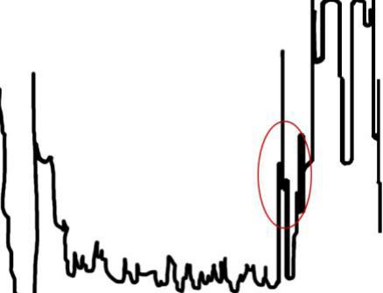

Figure A.1 Hole reflection waveform

A.2 Crack（Lamination）

The waveform appears as a reflection of the hole, as the probe is moved, the waveform moves with it. If the moving track of the probe is linear, the defect is a crack;If the moving track of the probe is area type, the defect is lamination.

A.3 Tungsten carbide accumulation

Waveform appears in the form of reflected wave with holes, but in an area, it usually appears in the form of reflected wave with multiple holes, and the peak value of reflected wave is relatively low. The typical reflection waveform is shown in figure A.2.
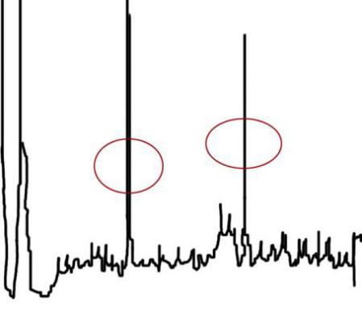
Figure A.2 Tungsten carbide accumulation reflection waveform

A.4 Cobalt aggregation

The reflection waveform of cobalt aggregation is of grass clutter, and the defect is of area type. The typical reflection waveform is shown in figure A.3.
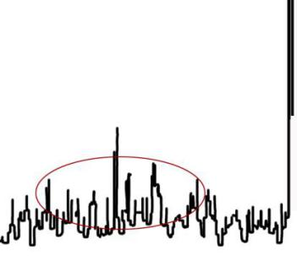
Figure A.3 cobalt aggregationreflection waveform

A.5 Mixed material

The reflection waveform of the mixed material is point-shaped waveform gathered by many small holes. The typical reflection waveform is shown in figure A.4.
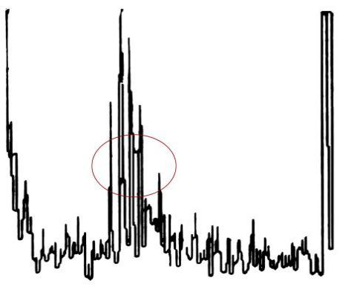
Figure A.4 Mixed material reflection waveform

A.6 Carburizing

Carburizing waveform appears in the form of more small hole reflection waves, also with some small clutter. The defect is of area type, generally distributed in the middle of the product, the typical reflection waveform is shown in figure A.5.
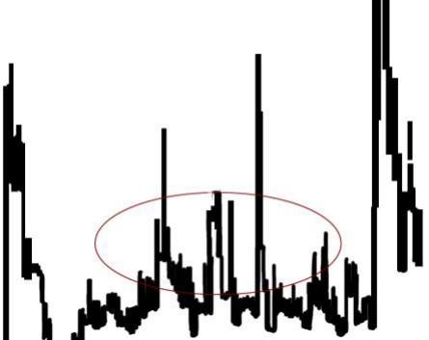
Figure A.5 Carburizing reflection waveform

A.7 Decarburization

The bottom of the decarburization reflection waveform is wide, and this defect generally appears on the surface of the product. The defect is of area type, and the typical reflection waveform is shown in figure A.6.
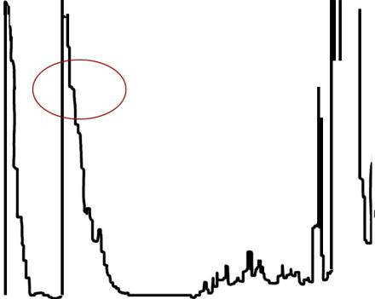
Figure A.6 Decarburization reflection waveform

A.8 Undersintering

Undersintered reflection waveform is of grass clutter, see figure A.7. The clutter waveform moves with the probe, and the defect is of area type.

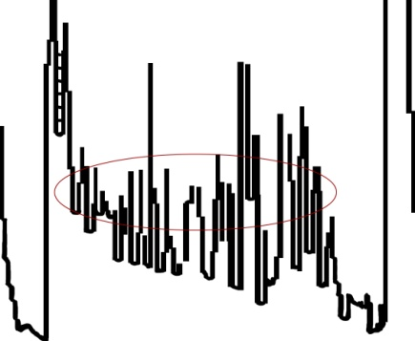
Figure A.7 Undersintered reflection waveform

A.9 Oversintering

Oversintered reflection waveform is of grass clutter, see figure A.8. The amplitude of clutter is high, the amplitude of product reflection waveform is low, even disappear, the defect is of area type.
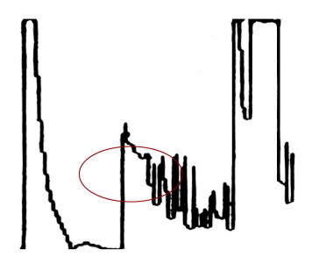
Figure A.8 Oversintered reflection waveform

